Q1: What is javascript language? Why javascript is popular?

JavaScript is a scripting or programming language that allows you to implement complex features on web pages — every time a web page does more than just sit there and display static information for you to look at — displaying timely content updates, interactive maps, animated 2D/3D graphics, scrolling video jukeboxes, etc. — you can bet that JavaScript is probably involved. It is the third layer of the layer cake of standard web technologies, two of which (HTML and CSS) we have covered in much more detail in other parts of the Learning Area.

1. JavaScript can be used in both the front-end and back-end of web development.
2. JavaScript is standardized, so it’s frequently updated with new versions.
3. JavaScript works with the document object model, or the DOM, to respond to user interactions. The DOM is the structure in the browser that displays a web pages.
4. JavaScript allows websites to have interactivity like scroll transitions and object movement. Modern browsers still compete to process JavaScript the fastest for the best user experiences. Chrome, the most used internet browser in 2017, has been so successful in part because of its ability to process JavaScript quickly.
5. JavaScript offers a wide range of frameworks and libraries that help developers create complex applications with low overhead. Programmers can import libraries and frameworks in their code to augment their application’s functionality.

Q2: What are cookies?

An HTTP cookie (also called web cookie, Internet cookie, browser cookie, or simply cookie) is a small piece of data stored on the user's computer by the web browser while browsing a website. Cookies were designed to be a reliable mechanism for websites to remember stateful information (such as items added in the shopping cart in an online store) or to record the user's browsing activity (including clicking particular buttons, logging in, or recording which pages were visited in the past). They can also be used to remember pieces of information that the user previously entered into form fields, such as names, addresses, passwords, and payment card numbers.

Cookies perform essential functions in the modern web. Perhaps most importantly, authentication cookies are the most common method used by web servers to know whether the user is logged in or not, and which account they are logged in with. Without such a mechanism, the site would not know whether to send a page containing sensitive information, or require the user to authenticate themselves by logging in. The security of an authentication cookie generally depends on the security of the issuing website and the user's web browser, and on whether the cookie data is encrypted. Security vulnerabilities may allow a cookie's data to be read by a hacker, used to gain access to user data, or used to gain access (with the user's credentials) to the website to which the cookie belongs (see cross-site scripting and cross-site request forgery for examples).

Q3: What is jQuery?

jQuery is a free JavaScript library. With jQuery you can write powerful JavaScript apps using fewer lines of code. jQuery is great for things like animations, Ajax requests, DOM manipulation, image effects, and user interface elements. jQuery lets you easily write cross-browser JavaScript code.jQuery is a lightweight, "write less, do more", JavaScript library.The purpose of jQuery is to make it much easier to use JavaScript on your website.jQuery takes a lot of common tasks that require many lines of JavaScript code to accomplish, and wraps them into methods that you can call with a single line of code.jQuery also simplifies a lot of the complicated things from JavaScript, like AJAX calls and DOM manipulation.

The jQuery library contains the following features:

* HTML/DOM manipulation
* CSS manipulation
* HTML event methods
* Effects and animations
* AJAX
* Utilities

Q4: What is CDN?

A content delivery network, or content distribution network (CDN), is a geographically distributed network of proxy servers and their data centers. The goal is to provide high availability and performance by distributing the service spatially relative to end users. CDNs came into existence in the late 1990s as a means for alleviating the performance bottlenecks of the Internet, even as the Internet was starting to become a mission-critical medium for people and enterprises. Since then, CDNs have grown to serve a large portion of the Internet content today, including web objects (text, graphics and scripts), downloadable objects (media files, software, documents), applications (e-commerce, portals), live streaming media, on-demand streaming media, and social media sites.[[3]](https://en.wikipedia.org/wiki/Content_delivery_network#cite_note-3)

CDNs are a layer in the internet ecosystem. Content owners such as media companies and e-commerce vendors pay CDN operators to deliver their content to their end users. In turn, a CDN pays Internet service providers (ISPs), carriers, and network operators for hosting its servers in their data centers.

CDN is an umbrella term spanning different types of content delivery services: video streaming, software downloads, web and mobile content acceleration, licensed/managed CDN, transparent caching, and services to measure CDN performance, load balancing, Multi CDN switching and analytics and cloud intelligence. CDN vendors may cross over into other industries like security, with [DDoS](https://en.wikipedia.org/wiki/DDoS) protection and web application firewalls (WAF), and WAN optimization.

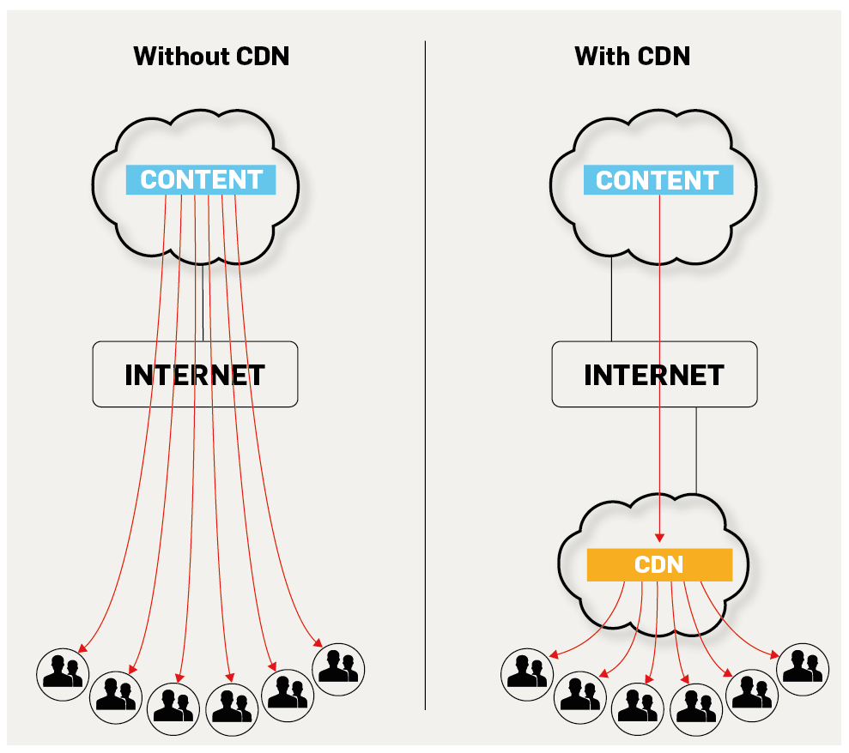

Q5: Create a hide/show functionality using jquery? - Create a p tag and add "Hello world!" in it. - Create 2 buttons i.e. One for Hide and other for show. - When user clicks hide, then the p tag should become invisible. - On clicking show, p tag should be visible.

ANS I have send externally

Q8: Parse a json file '{"name: "john doe", "age": 21, "city": "Montreal"}'. and show name, age and city on the html page using jQuery?

ANS I HAVE SEND EXTERNALLY

Q9: Write a code to perform gradient animation?

<!DOCTYPE html>

<html lang="en">

<head>

    <meta charset="UTF-8">

    <meta name="viewport" content=

        "width=device-width, initial-scale=1.0">

    <title>Gradient Background Animation</title>

</head>

<body>

    <section>

        <div>

            <h2>GeeksforGeeks</h2>

            <p>Gradient background Animation</p>

        </div>

    </section>

</body>

</html>

<style>

    body {

        margin: 0;

        padding: 0;

        animation: effect 3s linear infinite;

    }

    section {

        width: 100%;

        height: 100vh;

    }

    div {

        position: absolute;

        top: 50%;

        left: 50%;

        transform: translate(-50%, -50%);

        font-size: 3em;

    }

    h2 {

        text-align: center;

    }

    @keyframes effect {

        0% {

            background: linear-gradient(#008000, #00FF00);

        }

        50% {

            background: linear-gradient(#220080, #0084ff);

        }

        100% {

            background: linear-gradient(#e78f3c, #ff4800);

        }

    }

</style>

<!DOCTYPE html>

<html lang="en">

<head>

    <meta charset="UTF-8">

    <meta name="viewport" content=

        "width=device-width, initial-scale=1.0">

    <title>Gradient Background Animation</title>

</head>

<style>

    body {

        margin: 0;

        padding: 0;

        animation: effect 3s linear infinite;

    }

    section {

        width: 100%;

        height: 100vh;

    }

    div {

        position: absolute;

        top: 50%;

        left: 50%;

        transform: translate(-50%, -50%);

        font-size: 3em;

    }

    h2 {

        text-align: center;

    }

    @keyframes effect {

        0% {

            background: linear-gradient(#008000, #00FF00);

        }

        50% {

            background: linear-gradient(#220080, #0084ff);

        }

        100% {

            background: linear-gradient(#e78f3c, #ff4800);

        }

    }

</style>

<body>

    <section>

        <div>

            <h2>SUPREET</h2>

            <p>Gradient background Animation</p>

        </div>

    </section>

</body>

</html>

Q10: What is JSON and XML. Which one is better and why? Explain.

JSON stands for **J**ava**S**cript **O**bject **N**otation

JSON is a lightweight format for storing and transporting data

JSON is often used when data is sent from a server to a web page

JSON is "self-describing" and easy to understand

JSON is an open standard file format, and data interchange format, that uses human-readable text to store and transmit data objects consisting of attribute–value pairs and array data types. It is a very common data format, with a diverse range of applications, such as serving as a replacement for XML in AJAX systems.

* XML stands for eXtensible Markup Language
* XML is a markup language much like HTML
* XML was designed to store and transport data
* XML was designed to be self-descriptive
* XML is a W3C Recommendation

XML is a markup language which is designed to store data. It's popularly used or transfer of data. It is case sensitive. XML offers you to define markup elements and generate customized markup language. The basic unit in the XML is known as an element. Extension of XML file is .xml

JSON IS BETTER THAN XML,JSON is faster because it is designed specifically for data interchange. JSON encoding is terse, which requires less bytes for transit. JSON parsers are less complex, which requires less processing time and **memory** overhead. XML is slower, because it is designed for a lot more than just data interchange. JSON is best for simple applications, developed to satisfy simple requirements surrounding data interchange. XML is best for applications with complex requirements surrounding data interchange, such as in enterprise.